Parth Babbar

Personal Loans

**Introduction:**

Personal loans are popular financial products offered by banks, credit unions, and internet lenders that do not need collateral. These loans are used for a variety of objectives, such as debt consolidation, emergency expenses, and large purchases. This thorough book digs into the many forms of personal loans, their operational complexities, statistical analysis, market dynamics, regulatory frameworks, and critical elements that potential borrowers must consider when navigating this financial environment.

**What is Personal Loan?**

A personal loan is an instalment loan that people can get from banks, credit unions, or internet lenders. Unlike specific-purpose loans such as mortgages or vehicle loans, personal loans allow for greater flexibility in how funds are utilised, making them useful for debt consolidation, paying unexpected needs, and financing personal projects.

**How does Personal Loans work?**

1. **Application Process:** Applicants complete an application that includes financial information, job status, and the purpose of the loan.
2. **Credit Check:** Lenders use credit checks to determine the applicant's creditworthiness and may request extra evidence.
3. **Approval and Disbursement:** Once approved, the monies are disbursed in a lump amount. The repayment arrangements are agreed upon, including interest rates and monthly instalments.
4. **Repayment:** Borrowers return the loan over a certain length of time (usually 1 to 7 years) in monthly instalments that include both principle and interest.

**Features:**

1. Personal loans are usually unsecured, which means they don't demand collateral.
2. Most personal loans have fixed interest rates, which means the interest rate remains constant during the loan duration.
3. Personal loans typically vary from $1,000 to $50,000, allowing you flexibility in meeting a variety of financial requirements. These loans provide a variety of payback durations, ranging from 12 to 84 months, allowing borrowers to select a timeframe that is appropriate for their financial circumstances and repayment capacity.
4. Monthly fixed payments are necessary until the debt is paid off.
5. Approval is determined by the borrower's creditworthiness, income, and debt-to-income ratio.

**Types of Personal Loans:**

1. **Secured Personal Loan:** Secured personal loans are distinguished by the necessity for collateral, which can range from a savings account to a certificate of deposit (CD), giving lenders comfort and decreasing interest rates. This collateral also allows borrowers to obtain greater loan amounts and maybe negotiate better repayment arrangements. Secured loans are popular among people with low credit ratings or those in need of large sums of money. They provide a method to satisfy a variety of financial demands while leveraging the security of pledged assets.
2. **Unsecured Personal Loan:** Unsecured personal loans have no collateral restrictions and are approved entirely on the basis of the borrower's creditworthiness. Lenders use indicators including credit score, income, job history, and debt-to-income ratio to determine loan eligibility and conditions. The lack of collateral simplifies the application procedure, making unsecured loans a more convenient financing alternative for a variety of personal costs. Debt consolidation, home upgrades, weddings, holidays, and other discretionary expenses are common applications, providing borrowers with financial freedom without putting personal assets at risk.
3. **Fixed-Rate Personal Loan:** Fixed-rate personal loans have a consistent interest rate throughout the loan's term, ensuring borrowers' monthly payments are predictable and stable. This constancy protects borrowers from interest rate changes, allowing for more efficient budgeting and long-term financial planning. Fixed-rate loans are popular among people looking for consistent payment schedules and loan expense certainty. They are also great for those who value financial predictability and security throughout the loan period.
4. **Variable-Rate Personal Loan:** Variable-rate personal loans have interest rates that vary according to benchmarks such as the prime rate or LIBOR. They frequently begin with lower rates than fixed-rate loans during low-interest times, which might save borrowers money if rates fall further. However, payments might vary in response to interest rate fluctuations, thereby boosting costs if rates rise. Variable-rate loans are ideal for borrowers who can handle payment changes and want potential savings in favourable interest rate circumstances.

There are more types like Debt consolidation loans, Co-signed and joint loans, Personal line of credit, etc.

**Regulatory:**

Consumer protection in the field of personal loans is largely handled by the Consumer Financial Protection Bureau (CFPB), which oversees lenders to ensure fair lending practices and encourage transparency in loan conditions. Individual states also have their own rules governing personal loan interest rates, fees, and lending procedures. These state-specific rules play an important role in protecting borrower rights and influencing how lenders operate in each jurisdiction, guaranteeing compliance and improving consumer safeguards nationwide.

**Trends:**

1. The development of internet lenders has expanded access to personal loans by providing convenience and reasonable rates.
2. Higher credit scores often lead to cheaper interest rates and better lending terms.
3. Economic circumstances affect approval rates and interest rate variations.
4. Mobile applications and digital platforms make the loan application and approval processes more efficient.

**Interest Rate & Fees:**

**Interest:**

| **Credit score** | **Average loan interest rate** |
| --- | --- |
| 720-850 | 10.73%-12.50% |
| 690-719 | 13.50%-15.50% |
| 630-689 | 17.80%-19.90% |
| 300-629 | 28.50%-32.00% |

1. Personal loan interest rates average between 10% and 32%, depending on the borrower's credit score.
2. The interest rate is affected by the borrower's credit score, income, loan amount, and term.  
     
   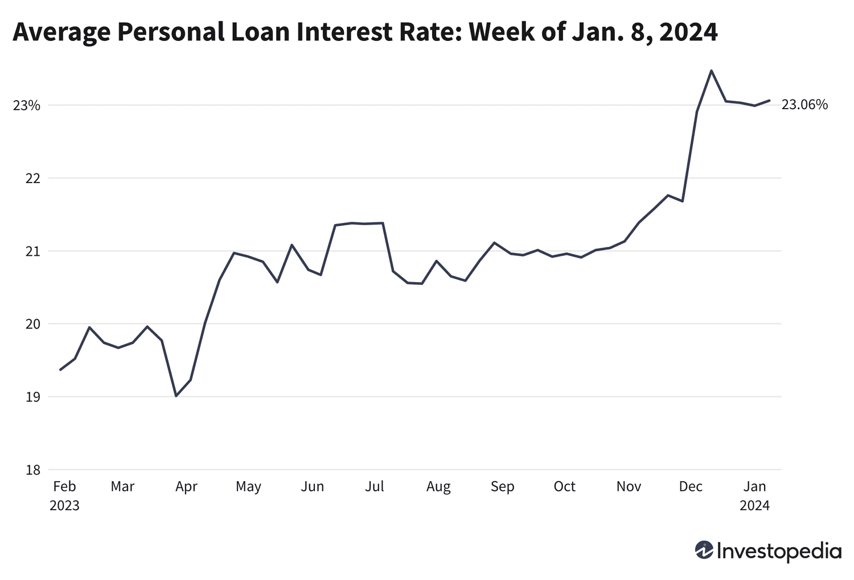

**Fees:**

1. Some lenders impose an origination fee of 1-6% of the loan amount.
2. Some loans may have early repayment penalties as well as charges for missing or late payments.

**Statistics:**

1. Personal loans are becoming increasingly popular in the United States. Over the last two years, outstanding balances for personal loans have climbed by about 59%, from $146 billion to $232 billion.
2. Personal loan interest rates average between 10% and 32%, depending on the borrower's credit score.

**Advantages & Disadvantages:**

**Advantages:**

1. Can be utilised for a range of applications.
2. Fixed interest rates and regular payments ensure certainty.
3. Most personal loans don't demand collateral.
4. Funds are often disbursed swiftly following approval.

**Disadvantages:**

1. Borrowers with low credit scores may incur exorbitant interest rates.
2. Failure to make timely payments might harm the borrower's credit score.
3. Some personal loans have origination fees or prepayment penalties.

**Conclusion:**

Personal loans are vital financial instruments that provide flexibility for a variety of needs. Understanding loan kinds, perks, concerns, and rules allows for more educated judgements. Monitoring market trends and successfully managing loans, particularly with regard to terms and rates, promotes financial stability and goal attainment.